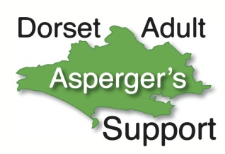
Can we continue to contact you?

New government regulations which came into effect on 25th May 2018 require us to ask you to confirm that you are happy for us to continue to contact you. We can’t assume this & have to ask you individually.

We may have the following personal details:
- Your name and email address so you can be on our mailing list and receive programmes and other news.
- Your ‘phone number so you can receive texts or calls related to our activities.
- Your postal address. Information about where you live can help us plan activities & events.
- Information relating to whether you or a family member or friend have an autistic spectrum condition, diagnosed or undiagnosed, or not. This helps us understand who needs & uses our service. It applies equally to people not on the spectrum such as carers and family members etc. as we aim to provide a service to meet different needs.

If you’d like us to continue to contact you, please confirm that we may keep this information.

We do not share your contact details with any other organisation and the information is kept confidentially by a very limited number of DAAS officials for the legitimate purposes outlined above.

Please confirm your permission for The DAAS Group to use your contact details by circling ‘Yes’ or ‘No’ below. NB The DAAS Group is for people aged 18 or over.
Please confirm E-mail address & phone no
E-mail | Yes | No
Telephone | Yes | No
Postal address | Yes | No
Your autism status | Yes | No

For the avoidance of doubt, being a member of the DAAS closed Facebook page does not imply we have your permission to contact you by other means.

You have the right to withdraw your permission at any time in the future.

Name: (Please Print) .........................................................................................................................

Signature: ..........................................................................................................................................

Date: ...................................................................................................................................................

